**Sinulog Festival in Cebu:  
Everything You Need to Know**

Sinulog Festival or Santo Nino Festival is an annual religious and cultural festival in **Cebu** . The festival is thought to be the first of the most well-known festivals in the Philippines.

It also attracts between 1 to 2 million visitors from all over the country every year and gives travelers the opportunity to join Cebu tours to explore the province.

Besides the religious part of the celebration, Sinulog is also well-known for its street parties before the day of celebration and during the day of the festival.

**History of Sinulog Festival**

Sinulog is held in celebration of one of the country’s most famous historic relics: the Santo Niño de Cebú. This was the statue of the baby Jesus that was handed to the Rajah Humabon of Cebu by the Portuguese explorer Ferdinand Magellan in 1521.

This was one of the most important events in the religious history of the Philippines as it paved the way to the birth of Christianity in the country.

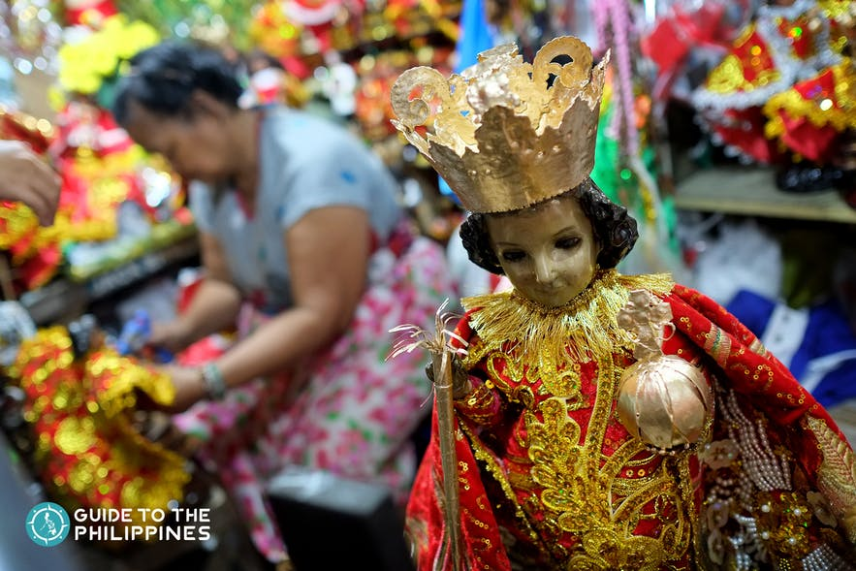

At the moment of receiving the holy image, it was said that Queen Juana, the main consort of Rajah Humabon, danced with joy holding this image of the child Jesus.

The other natives followed her example, and this event was regarded as the first Sinulog dance. The same event was used as the basis for most Sinulog dances.

The Sinulog dance steps are also believed to originate from Baladhay, Rajah Humabon's adviser. When Baladhay got sick, Humabon ordered his tribe to bring Baladhay into a room where the Santo Niño was enthroned.

After a few days, Baladhay was heard shouting and was found dancing by the native tribe. Baladhay was asked as to why was he was shouting and dancing. He pointed at the image of the holy Jesus and explained that baby Jesus was tickling him.

In turn, Baladhay danced with the little child and explained that he was dancing the movements of the river. To this day, the two-steps forward, the one-step backward movement is still used by Santo Niño devotees who believe that it was the Santo Niño's choice to have Baladhay dance.

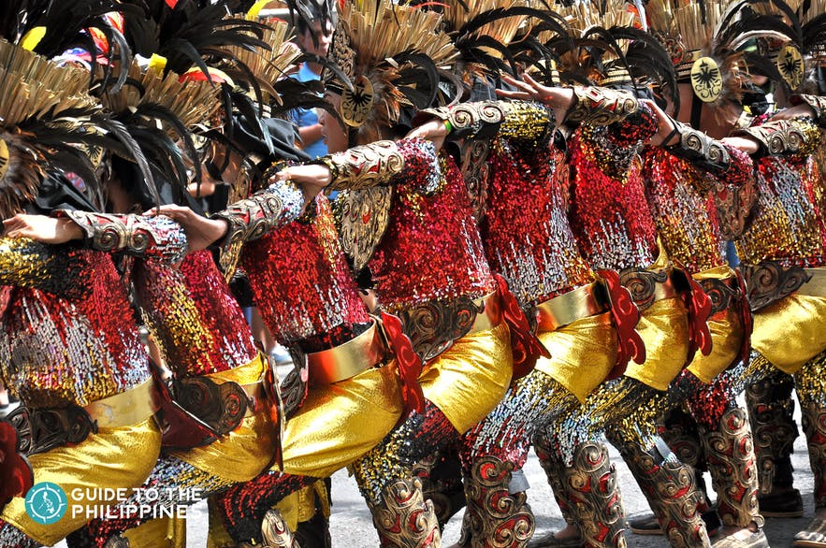

**Meaning of Sinulog**

Sinulog comes from the Cebuano word “sulog” which means “like water current movement” which depicts the forward-backward step of Sinulog dance.

**When is Sinulog celebrated?**

Sinulog Festival is held every third Sunday of January. For 2020, it falls on the 19th of January. This is why it's highly recommended to go to Cebu a few days before the Sinulog festival and stay for a couple more to fully experience the events and also explore the province.

**What to Expect**

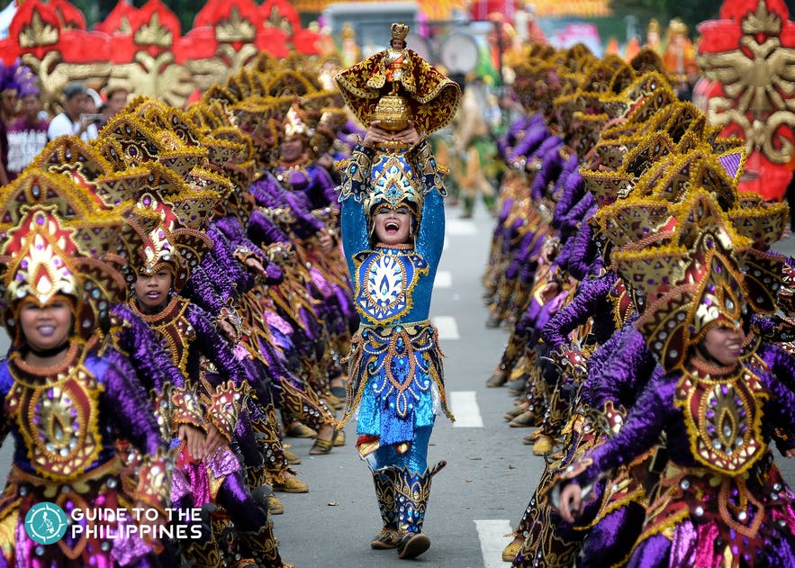

**Things to Do during Sinulog Festival**

Watch the grand parade

This is the main event and this is where locals show off their creativity and fun side. The Sinulog grand parade can rival the colorful festival of Rio and is considered the most colorful festival in Asia.

Join the street parties

Prior to and after the main parade, street parties are everywhere in Cebu during the evening. So join the locals, get your face painted and get a beer shower.

Enjoy the food

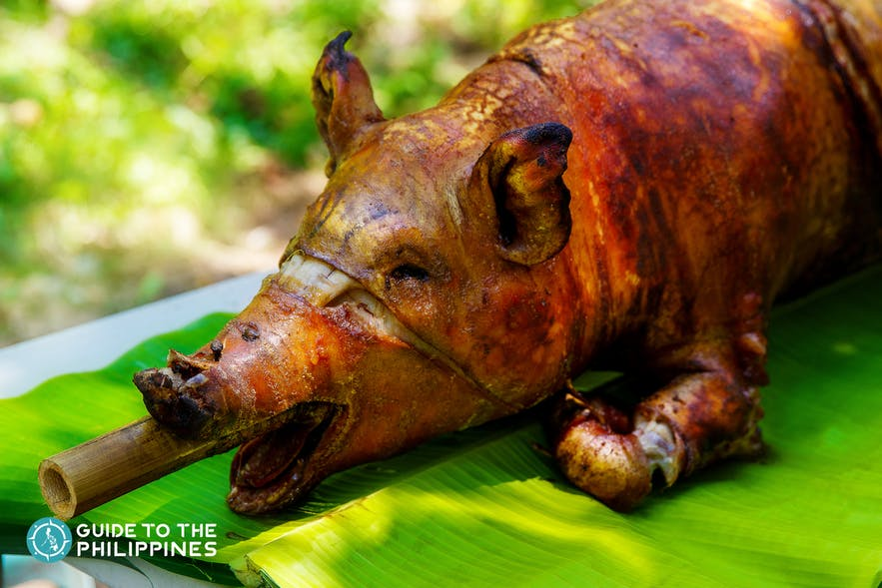

Cebu is one of the best places in the Philippines to enjoy Filipino foods. From the famous Lechon, rumba, b-ami or Puso, you will for sure enjoy the local delicacies in Cebu.

Watch the fireworks

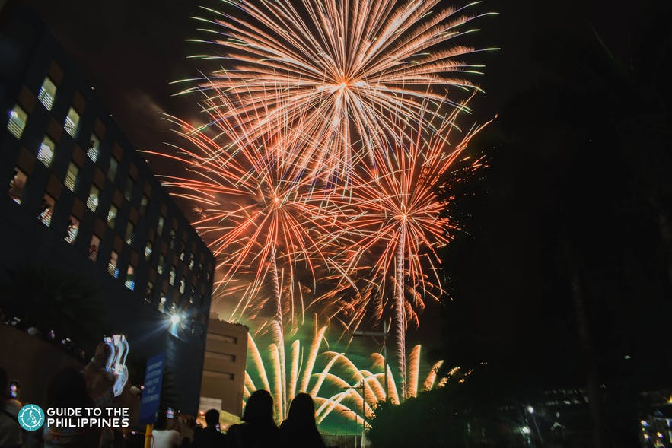

Join the grand finale of Sinulog festival with a bang by watching the fireworks display in the evening.

Explore the city

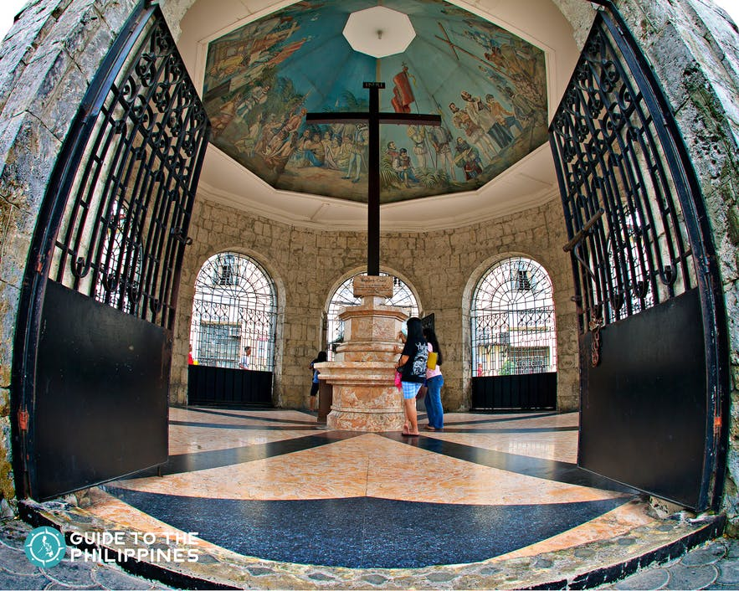

Cebu is known for its history. So take a night walk from Basilica Minore del Santo Niño to Magellan’s Cross, offer a candle and prayers while learning about the colorful history of Cebu. Join a sightseeing tour, historical tour, or pilgrimage tour that you can add to your Cebu itinerary.

*Source: Internet*